April – June 2014
BCMF Quarterly Report
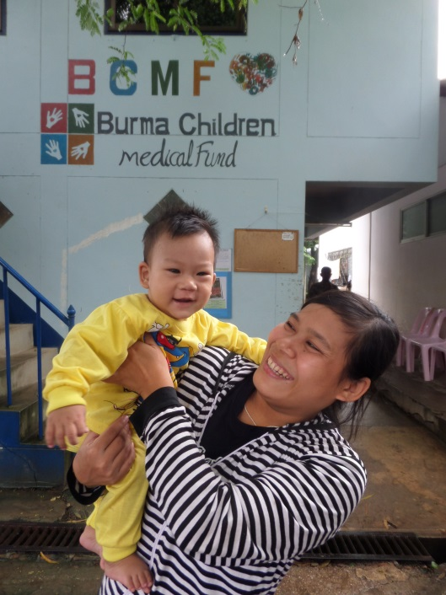

Program Director: Kanchana Thornton
Phone: +66 898 988 694
Email: administrator@burmachildren.com
Website: www.burmachildren.com
Facebook: www.facebook.com/burmachildren
Twitter: www.twitter.com/burmachildren

Overview

Half way through the 2014 program year, BCMF continues to strengthen our three programs (Burma Children Medical Fund, Burma Adult Medical Fund and Burma Women Medical Fund) while faced with new obstacles to fund complex medical treatments. Our major challenge in this period has been adapting to a change in funding arrangements with Child’s Dream Foundation – one of our biggest partner organizations – who will no longer provide treatments for patients with congenital musculoskeletal deformities and neurological conditions as of August 1, 2014. In 2013, roughly one-third of all BCMF patients referred to CDF sought medical care for these kinds of conditions. This loss of support will have a further impact on BCMF’s ability to meet medical demands along the Thailand-Burma border.

Program Highlights and Updates
Over the years, BCMF formed direct relationships with staff from partner organizations in order to reach more patients with treatable conditions; this year has proven no exception. Working with dedicated medical professionals such as Nor Ree, Reproductive Health Out Patient Department Supervisor at Mae Tao Clinic, ensures that all eligible patients know and understand that treatment is always an option with the help of BCMF. Thanks to her hard work this period, Burma Women Medical Fund (BWMF) has been able to assist three times the number of women to receive operations for myoma, ovarian cysts, uterine prolapse, and other gynecological conditions since last quarter. The fund supported 48 cases last year and is on track to meet the same results, with 22 BWMF patients treated so far from January-June.

Another reason for BWMF’s success is the continued support from Anna Le Masurier’s generous monthly donation via Macquarie Bank’s matching fund program and Watsi – a crowd-funding platform with a mission to fund high-impact, low-cost surgeries for patients who cannot afford them. From August 2013 until June 2014, Watsi helped BCMF partially or wholly pay for 142 patients’ medical treatments from all three programs (Watsi has a cap of $1,500 per patient). Gynecological cases comprised 30% of all Watsi supported surgeries, thus significantly strengthening our ability to sustain this program. Unlike medical care received in Chiang Mai, Watsi funding covers the entire cost of most gynecological operations performed at Mae Sot Hospital, where treatment and logistical fees are less expensive.

As for the total number of patients served, BCMF saw the usual decline in patient intake associated with the second quarter. April through June marks the arrival of the rainy season during which roads become obstructed, making the long trip to Thailand both difficult and dangerous. It is also the start of the growing season in Burma when many are busy planting crops for the year. Lastly, this quarter coincides with Songkran, also known as the water festival, which heralds the start of the New Year of the Buddhist calendar. It is typically celebrated by a five day-long bank holiday during which public services are limited or discontinued. For these reasons, BCMF saw 46 new patients at this time last year, which is on par with this year’s 51 new additions to all three programs.

Continued Funding Limitations
Unfortunately, resources continue to filter from organizations along the Thailand-Burma border into those operating inside Burma. This trend threatens to limit the types of conditions we are able to treat. In 2014, BCMF has had to make the very difficult decision, due to financial reasons, to no longer take patients diagnosed with cancer and other long-term, complex conditions. This change has been very difficult for us to put into effect. BCMF is the last resort for many patients who have been unable to access medical treatment in Burma and made the long journey to Thailand in hope of a cure. When we cannot provide assistance, no other organizations along the Thai-Burma border can secure complex treatments in specialized Thai health facilities for refugees and migrants from Burma. We are aware of the enormity of this decision but until we can access greater sources of funding for these types of conditions, BCMF cannot channel much needed resources into expensive treatments for patients with cancer and other long-term complex conditions.

Sadly, we do not face this challenge alone. Our partner organizations have also been hurt by funding constraints, which directly affects BCMF’s ability to serve our growing caseload. Child’s Dream Foundation (CDF) – which assisted with 35% of all BCMF patients registered in 2013 – has restricted the types of conditions they treat and overall caseload. Starting in August 2014, CDF can no longer accept patients with congenital neurological disorders (such as spina bifida and meningocele), and muscoskeletal deformities (such as cleft lip, clubfoot and abnormal spine formations). Last year, CDF assisted 10 BCMF patients with these conditions, making up approximately one-third of the total number of those referred. The loss of CDF’s support for these conditions makes it more difficult for BCMF to meet the demand for our medical services and adds increased burden on our financial resources.

Congenital neurological conditions, such as meningocele, are one of the most common congenital conditions present in Burma where 1 out of 5,000 babies are born with a meningocele – compared to 1 in 40,000 in western countries. The condition is defined by the failure of the neural tube to close in utero. As a result, spinal membranes form a cerebrospinal fluid filled cysts in the skull or along the spine. Most healthcare facilities in Burma are not equipped with surgical tools and expertise to drain and close the opening. Therefore, many cases go untreated, causing damage to the brain and central nervous system. BCMF and CDF send children diagnosed with meningocele and other forms of spina bifida, to Suan Dok Hospital in Chiang Mai where they can get specialized treatment, therefore helping to reduce the rates of morbidity and mortality caused by the condition.

As for muscoskeletal deformities, treatment can be a long, in-depth process. Talipes, also known as clubfoot, can be corrected more quickly with better results when the surgical procedure occurs soon after birth. Once old enough to walk, the body’s weight puts pressure on tendons, joints and bones, further aggravating the condition. According to Global Club Foot Initiative, 80% babies born with talipes are in low and middle-income countries where the impediment makes it difficult to travel, attend school and work. Unfortunately, most patients from Burma come to BCMF when older and require multiple corrective surgeries, follow-ups, and physical therapy appointments.

Furthermore, Suan Dok Hospital, where the vast majority of BCMF patients go for treatment and investigations, are raising their costs, putting additional strain on our resources. In 2013, the hospital began to enforce “foreigner fees” for non-Thai nationals. BCMF patients already pay as private users of the publically funded medical system. These rising costs make it difficult for BCMF to maintain our growing caseload, and serve as an impetus for building relationships with hospitals in Burma. BCMF strives to reach patients earlier in their illness thus reducing the financial pressure on both our patients and BCMF while increasing their chance of a full recovery.

Rubella Vaccination Screenings
BCMF is furthering efforts to not just treat but prevent congenital conditions from occurring. At the start of the program year, BCMF began a rubella screening and vaccination program for women of childbearing age. Rubella is reportedly not part of the regular immunization schedule in Burma and is only available in private hospitals. If a woman contracts the virus in her first trimester, the baby has a 90% chance of developing congenital rubella syndrome (CRS) , which could result in a range of congenital conditions including heart disease, hearing and visual impairments, and developmental disabilities. A one-time only vaccination against rubella can prevent the transmission of CRS.

Based on research from SMRU, migrant workers along the Thai-Burma border are some of the most difficult populations to vaccinate due to their mobility and fear of being caught by local authorities when going to public health centers for immunizations. BCMF has both direct access to undocumented migrants and refugees from Burma and rubella vaccinations – thanks to our partnership with Mae Tao Clinic – placing us in a unique position to facilitate this neglected health service. As part of the initiative, patients are asked about their vaccination histories and referred to MTC staff to administer the immunizations.

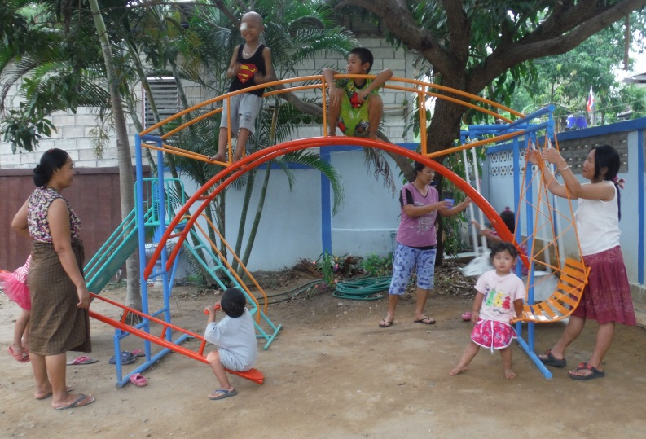
A BIG THANKS!

BCMF would like to say a big thank you to the British Community in Thailand Foundation for the Needy (BCTFN) in Bangkok for providing the perfect addition to our Chiang Mai patient house - a jungle gym! We would also like to thank Gail Bailey for all her fantastic help. Now, children are able to play in the front garden as they recover from their medical treatment – further making the house their home.

Patients
This quarterly report highlights BCMF patients with congenital conditions who received support from CDF. Funding treatments for patients with meningocele and clubfoot, like Wai and Paw Nay, is becoming increasingly difficult on the Thailand-Burma border.

April Spotlight: Yel Kyaw
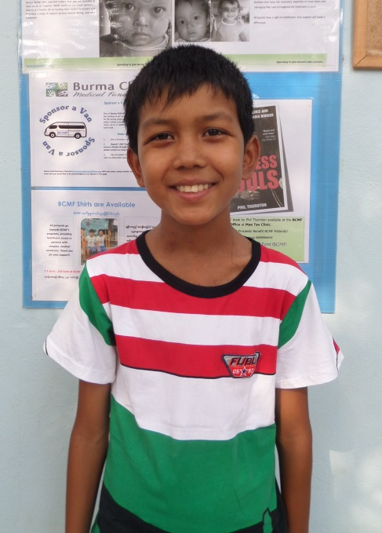
Yel Kyaw is a twelve year old boy from Mon State, Burma who came to Mae Tao Clinic suffering from severe mitral regurgitation, or MR. Mitral regurgitation is a heart defect in which the mitral valve – the dual-flap valve in the heart that controls the flow of blood between the left atrium and left ventricle – doesn’t close properly, thereby allowing blood to leak back (regurgitate) into the left atrium.

Yel Kyaw’s symptoms first appeared when he was 8 years old. He was fatigued by simple activities such as cycling to the market. When his complaints about loss of breath and energy persisted, his mother took him to a free local army clinic nearby for a checkup. The doctor there said Yel Kyaw had a cardiac condition and wrote a referral letter for further treatment in Rangoon.

In October 2010, Yel Kyaw and his mother went to Rangoon Children’s Hospital for an x-ray, urine test, blood test and echocardiogram. The results showed he had severe mitral regurgitation. Doctors said it would cost 5,000,000 kyat (USD$5,000) to perform the life-saving operation. Shocked, Yel Kyaw’s mother told the doctor they would not be able to afford such an expensive treatment. Medical staff then referred him to Yan Kin Children’s Hospital in Rangoon where he was prescribed medication instead of undergoing surgery. He continued taking the medication for over three years. During that time his condition remained fairly stable, but did not improve. Two years ago, he had to stop going to school because his fatigue made it too difficult for him to concentrate.

Yel Kyaw’s family never sought further treatment for him in Burma. They were still paying off debts accrued from his medical costs in Rangoon. Knowing this, a friend of their family working with the Back Pack Health Workers Team suggested they come to Mae Tao Clinic for help. The medic organized the journey, traveled with them and paid for all their costs along the way. After an echocardiogram screening at Mae Sot Hospital revealed his mitral regurgitation, he was referred to BCMF.

On 18 March 2014, Yel Kyaw received surgery to repair his mitral valve at Chaing Mai Hospital. His mother says everything at the hospital and patient house was very comfortable for them. CDF staff did a fantastic job translating what the doctors said and explaining about her son’s medical treatments. Their experience in Chiang Mai was completely different from visiting hospitals in Burma. The main difference being that in Thailand, staff takes care of their patients very well, regardless of their financial situation.

Before surgery, Yel Kyaw was always very tired; he couldn’t play, run or do very simple things without suffering from exhaustion. Now, he feels much better and is markedly more energetic. He’s desperate to start playing football again but the doctors have warned him to take it slowly! Yel Kyaw is also looking forward to returning to school after two years of having to stay at home. He’s particularly interested in science and wants to be a schoolteacher when he grows up.

His mother wants to give a very big thank you to everyone who has been involved in her son’s treatment and supported his recovery – she knows that in Burma, this would never have been possible.

May Spotlight: Wai
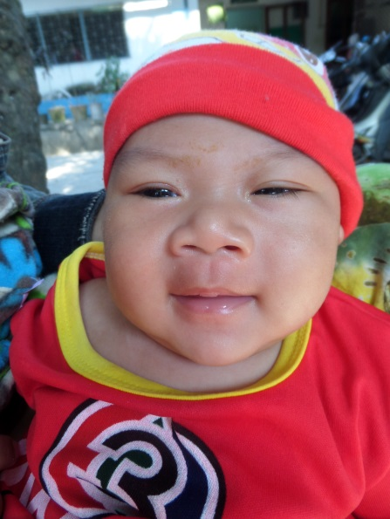
Wai is a seven-month-old baby boy from Mae Htaw Ta Lay, near Myawaddy in Burma. He was referred to BCMF in February after being diagnosed with meningocele.

Wai is his parent’s first child who was born from a natural birth at Mae Tao Clinic (MTC) without any complications. However, his mother noticed a small lump on his lower back after she returned home from the clinic. She wasn’t able to see a doctor until she brought him back to MTC for his vaccinations. It was only then that doctors diagnosed Wai with meningocele and referred him to BCMF for further care.

On 6 February 2014 Wai and his mother were sent to Chaing Mai Hospital for a CT scan, which revealed that he will need surgery. Following the first appointment, he and his mother returned to Burma where they waited for Wai’s operation date. They returned to Chaing Mai in May and on the 20th he was admitted to hospital. He underwent surgery on the 26th, but on the 29th he had to have another operation because, while doing a routine check, the doctor noticed that the cyst on his lower back had returned. On 6 June, Wai had to undergo surgery once more, as the cyst had still not been completely removed. Following the success of the third operation, he was discharged on 23 June.

While her son was in hospital, his mother noted that the doctors and nurses were kind and took very good care of her son. She explained that CDF staff in the patient house were very supportive and assisted with all of their needs. She said, “When I saw my baby had a mass on his back I felt so heartbroken, so sorry for him. Now that he has had the mass removed, I am very happy.”

Now, her son is an active, playful, and “completely delightful” child. His mother is so relieved that there were no complications from the surgery and his legs are strong and healthy.

Wai’s mother says thank you to all of the donors and everyone who was involved with her son’s treatment. In the future, she would like her son to be educated. She and her husband both have to do hard physical labor to earn a living and she wants a better life for her son. If he is educated, she says, he will have more employment opportunities and a higher standard of living than the one she and her husband have been able to provide.

June Spotlight: Paw Nay
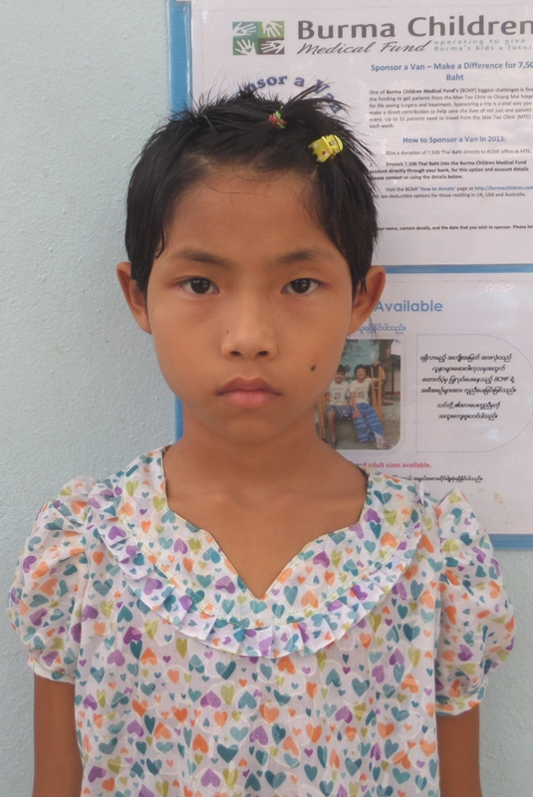
Paw Nay is a ten-year-old girl who was referred to BCMF from Mae Tao Clinic in June 2014. She suffers from bilateral clubfoot – a congenital condition that causes both feet to turn inwards and downwards. Paw Nay’s condition makes walking very difficult and painful. The skin on the tops of her feet have cracked and hardened, and the prolonged weight on her ankles causes them to swell and bleed.

Paw Nay’s parents have known about her condition since birth. The doctor diagnosed her with clubfoot but told her parents that there was nothing he could do to correct their position. Refusing to give up, her parents took her to a public hospital in Bago two months later. The hospital staff there had the same response – they would not be able to provide treatment. This time, they recommended that she go to Rangoon Hospital. Her parents knew the costs of travel and treatment would be too much for them to afford. Frustrated, they returned to their village.

With no other options, Paw Nay adapted to her bowlegs and started walking on the sides of her feet. At first, her ankles would frequently bleed as a result of the pressure. Her mother would apply bandages to her feet, store-bought medicine to her wounds, and herbal lotions to relieve the pain. Over the next six years, Paw Nay continued to do the best she could without any medical assistance.

Paw Nay currently attends grade 4 at her local school along with three of her siblings. She enjoys class but finds the thirty-minute walk there and back very difficult – especially during the rainy season when the road becomes treacherous and slippery.

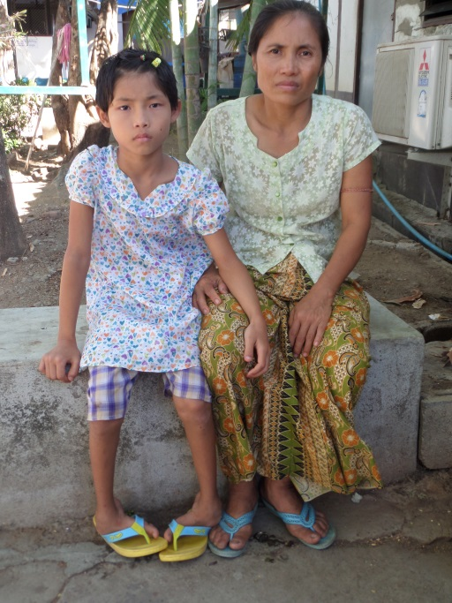
In May 2014, Paw Nay’s second cousin advised her parents to bring her to Mae Tao Clinic in Thailand in hope of medical care. Her parents stopped working on their farm and made the two-day journey from their village to Myawaddy. Soon after they arrived at Mae Tao Clinic, where they referred to BCMF.

According to her mother, the greatest difficulty the family faces is accessing healthcare in Burma. The high costs of treatment and transportation means Paw Nay’s parents are unable to do anything to help their daughter. “If you don’t have money, you don’t have options… you are just left to die,” she said.

Paw Nay says she wants to have surgery so she can look like her friends. She wants to continue with her education and study hard so that one day she can become a teacher. Her mother agrees: “It will be good for her and good for the family.” Her family is upset by Paw Nay’s situation and will bring them great joy to see her receive treatment and walk normally.

In Memoriam

In some cases patients only come to Mae Tao Clinic and BCMF after they have been sick for a long time. Many seek treatment in Burma but are ultimately unable to afford the costs of medical care. With no other options, many patients simply live with their symptoms until they hear about Mae Tao Clinic and BCMF from a friend or neighbor. BCMF would like to remember our fighters.

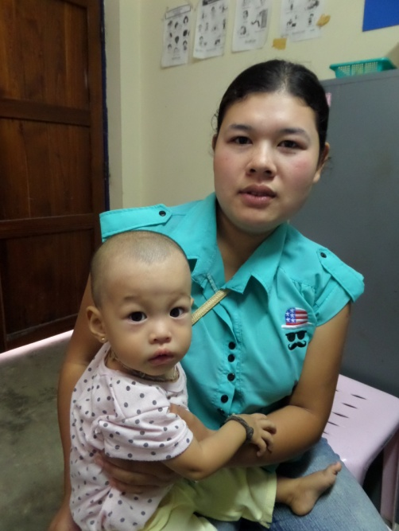
Nar
Nar came to BCMF in July 2013 when she was suffering from ventricular septal defect (VSD) and atrial septal defect (ASD) – congenital cardiac defects defined by abnormal openings between the dividing walls of the ventricles and the atria.

When Nar was five months old, her mother noticed that she had a cold so she took her to a private clinic in Phoh Prah. She was prescribed medication but, after taking it on and off for a few months, she didn’t get any better. Her heavy coughing led the clinic’s medical team to believe she had a lung problem.

The next time Nar fell sick, her parents brought her to Mae Tao Clinic, where she was admitted for two days. Doctors diagnosed her with a cardiac condition as well as moderate malnutrition and a B1 deficiency. She was prescribed medication then referred to Lampang for an echocardiogram screening. The results revealed that she was suffering from VSD and ASD. After a series of further investigations, she was sent to Chaing Mai Hospital for an operation on the 12 June 2014. Unfortunately complications occurred post surgery and Nar passed away on 24 June.

BCMF expresses our heart-felt condolences to Mi Nar’s family for the extreme hardships they’ve endured.

Saw Yin
17 year old Saw Yin came from Shwe Jin Nyaung Lay Bin, a rural town in Bago Division, Burma. He was referred to BCMF from MTC in December 2013, after months of suffering from a common bile duct stone.

Saw Yin lived with his mother. The two worked together as subsistence farmers, growing vegetables on a small plot of land and panning for gold in the local stream. Saw Yin attended school for only two years before having to discontinue his studies to help his mother earn money.

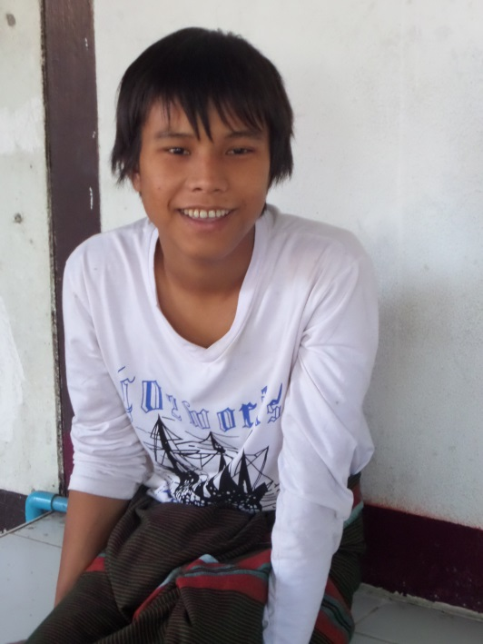
Saw Yin’s father and sister had also passed away at home from preventable conditions. His father died of a severe cough and fever when he was only five years old, and his sister passed away two years later while Saw Yin was training to be a monk in a local monastery. His family was unable to afford the cost of medical treatment in a hospital, preventing them from seeking help from the nearest healthcare facility five hours away.

For the past two years, Saw Yin experienced intermittent episodes of pain underneath his breastbone. Eventually, the pain radiated throughout his right side and back. He tried to treat himself with traditional medicine but the pain only worsened. Last year he went to Nyaung Lay Bin Hospital where he was prescribed medication – which didn’t help – for a condition no one told him any details about.

In November 2013, the pain was unbearable and Saw Yin began vomiting blood. He went to a clinic in Thein Za Ye, which then referred him to a hospital in Bago. After receiving an x-ray and an ultrasound, the doctor there told him he had a stone in his bile duct and it would cost 1 million kyat ($1,000 – 2,000 USD) to have removed. Saw Yin didn’t even have 10,000 kyat to pay for the x-ray, so he had to return home. His cousin, however, insisted he get medical treatment at Mae Tao Clinic (MTC).

He arrived at MTC in December 2013 and was referred to BCMF soon after. Saw Yin was then sent to Chiang Mai Hospital, where he was receiving treatment and extensive investigations. His severe abdomal pains persisted, causing his 6-month stay in Chiang Mai to be filled with frequent trips to the emergency room to stabilize his condition. His final diagnosis was an acute chronic pancreatitis with pancreatic duct stone and pancreatic pseudocyst hemorrhage.

Saw Yin’s mother was unable to stay with him in Thailand because she needed to continue farming. There was a lot of work to do without the help of her son and Saw Yin worried about how she was managing with him so far away. By May his condition stabilized and his surgery was scheduled for October, so he requested to return home to spend time with his mother – the only family he has left. Saw Yin died suddenly 10 days later in his village, far from any medical center that could have treated him.

BCMF would like to extend our deepest condolences to his mother, for all the hardship she has endured, and express our sorrow at the tragic passing of her son.

BCMF Program Statistics
April – June 2014

 | 2nd Quarter | 1st Quarter
Total number of new cases across the program | 51 | 73
Children- BCMF | 9 | 23
Children- CDF | 16 | 21
Adult- BAMF | 10 | 23
Gynecological cases- BWMF | 16 | 6
Diagnoses
Cardiac Disease | 14 | 17
Obstetric/Gynecological Condition | 16 | 8
Gastrointestinal Condition | 6 | 5
Eye Condition | 2 | 4
Neurological Condition | 2 | 5
Benign Growth/Benign Tumor | 2 | 8
Congenital Musculoskeletal Deformity | 2 | 4
Urological/Kidney Condition | 2 | 4
Cancer | 1 | 4
Severe Burns | 1 | 3
Blood Disorder | 1 | 3
Other | 2 | 8
Patient’s home state/division
Karen State | 26 | 26
Tak Province | 11 | 25
Bago Division | 5 | 1
Mon State | 4 | 8
Mandalay Division | 2 | 1
Shan State | 1 | 5
Ayeyarwady | 1 | 0
Sagain | 0 | 2
Rangoon | 0 | 1
Rakhine | 0 | 1
Thailand | 1 | 3

BCMF Cases Registered with CDF from January to June 2014

Total Cases | 34
Cardiac Disease | 15
Gastrointestinal Condition | 8
Congenital Musculoskeletal Deformity** | 6
Neurological Condition** | 4
Urological/Kidney Condition | 1

**CDF is no longer able to support patients with congenital musculoskeletal deformities and neurological conditions.

World Health Organization, Regional Office for South-East Asia. (2013). Birth Defects in South-East Asia: A Public Health Challenge, Situation Analysis, p.65, found: http://apps.searo.who.int/PDS_DOCS/B4962.pdf.
Holm, C.; Thu, M.; Hans, A; Martina, M.; Silvia, G.S.; Moritz, S.; & Wolfgang, M. (2008). Extracranial Correction of Frontoethmoidal Meningoencephaloceles Feasibility and Outcome in 52 Consecutive Cases. Plastic and Recovery Surgery 121(6), pp.386e-395e.
Ibid.
Global Clubfoot Initiative. Clubfoot in Low and Middle Income Countries (LMIC). Accessed 10 August 2015 at http://globalclubfoot.org/clubfoot/low-middle-income-countries/.
World Health Organization, Regional Office for South-East Asia. (2013). Birth Defects in South-East Asia: A Public Health Challenge, Situation Analysis, p.65, found: http://apps.searo.who.int/PDS_DOCS/B4962.pdf.
World Health Organization. (July 2012). Rubella Fact Sheet N.367. Accessed July 2014 at http://www.who.int/mediacentre/factsheets/fs367/en/.
March of Dimes. (2006). Global Report on Birth Defects; The Hidden Toll of Dying and Disabled Children. Accessed July 2014 at http://www.marchofdimes.com/materials/global-report-on-birth-defects-the-hidden-toll-of-dying-and-disabled-children-full-report.pdf.
Canavati, S.; Plugge, E.; Suwanjatuporn, S. & Nosten, F. (2011). Barriers to immunization among children of migrant workers from Myanmar living in Tak province, Thailand. Bulletin of the World Health Organization. Accessed: http://www.who.int/bulletin/volumes/89/7/10-084244/en/.

